Track My Fish App Instructions
2026 Twin Rivers Bream Classic

Prepare for the Event
Download the TRACK MY FISH FOR TOURNAMENTS app from Google Play or the Apple App Store.

If you have already downloaded the app, check for updates. The app must be used in the most current update.
Open the app & pop-ups will appear. Allow/Don’t Allow Notifications. Choose your preference.
Have you used any TMF/Info fish apps before?
→Yes – enter email/password and login
→No – click to register
When logging in or signing up if you receive any pops up that says invalid or username already in use, please contact:

Track My Fish as you may already have a profile at Stefan Sawynok 0409 811 551 or email stefan@infofishaustralia.com.au

SELECT GROUP – Twin Rivers Bream Classic
RECORD CATCH
Press RECORD CATCH, SELECT THE EVENT you would like to fish in, Twin Rivers Bream Classic and press ENTER

It will indicate if the event is live. If so, press ENTER.

During the Event – Log Your Catch

PHOTOSTREAM | make sure the SAVE TO CAMERA ROLL button at the top is ON (set to green). Once a catch has been submitted these photos will save to your phone camera gallery as a backup.

OFFLINE MODE | turn your phone to offline mode. This saves your battery power when in areas of low reception. To go offline, click the green button. This will show ONLINE when green and grey when OFFLINE.

You will still be able to use the APP as per usual in OFFLINE mode to log your catches. Once back in range, if you have a minimum of 3-bars of 4G mobile reception, turn this back on - to ONLINE and you will be prompted to submit what you have caught.
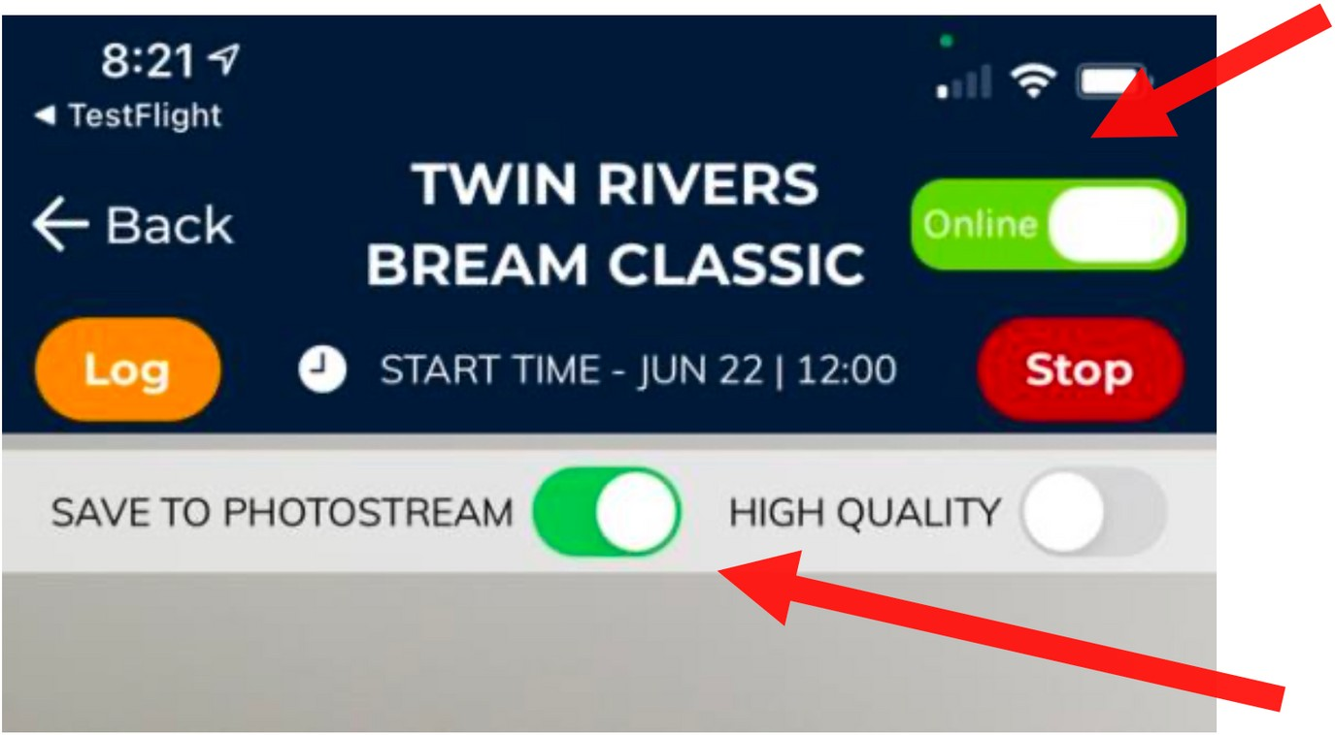

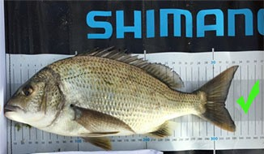

Measure from fork not tip

Take a clear photo as directed by the events’ requirements of measuring a fish in the app - click the BLUE TICK, then click GLORY PHOTO and take photo of you holding the fish, press BLUE TICK.
At the bottom of the screen enter the fish details:
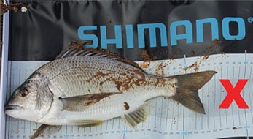
→Enter the first name & last name of the fisher to assign the fish to.
→Select the species.
→Choose your fishing category – BAIT or LURE
→ (Measure the fish to fork and round down to nearest 1/2 cm.
For example, 40.8 to the fork rounds down to the nearest ½ cm e.g. 40.5
→It is recommended photos are shot in landscape mode and from directly
above the fish clearly showing the fish and measure mat.
→Once all the photos and data are loaded, press SUBMIT button

Frequently Asked Questions
How can I see if my fish score is submitted?
- When in the record catch screen, in the top left of the screen is a LOG button. Press this button. The list of your logged fish will show. Under each log, it will show if the data & image has been received. For example:
- If it reads green RECEIVED, it means the data AND the image have been received on the server.
- If it reads red NOT SENT it means neither the data nor images has been sent and therefore not received.
- If it reads orange IMAGE NOT SENT it means the data has been received (fisher, length, type etc.) but the images have not been received.
- If you have either the red or orange, you will need to press the SUBMIT ALL button located on the top right of the screen so it re-uploads. Please keep checking until all your logs show green.

Where can I find my scorecard?
- If you are wanting to check your tally of scores, click the INFORMATION tab and then you have the scorecard tabs to click.
- If you see ACCEPTED IMAGE RECEIVED next to the entry, it is confirmation that the fish has been accepted and therefore your score for that fish is on the server i.e., no discrepancies in your scoring.
- If you see SUBMITTED IMAGE RECEIVED, it means the data and image have been received but the official score checker is yet to verify and accept your entry. This simply means the data is still to be checked.
- If you see SUBMITTED IMAGE NOT RECEIVED, it means the data has been received but not the image. Go to the LOG page in the previous question and follow the resubmission steps.
- If a submission is missing, it’s either been rejected (the score does not count due to breach of rules) or nothing at all has been received. If your submission is missing, go back to your log (see the previous question) and check your data has been uploaded.
- If it is showing as green RECEIVED and the submission is not in the CHECK MY SCORE, your fish has been rejected.
- ***ALWAYS CHECK YOUR SCORECARD AND LOG AT THE END OF A SESSION FISHING ***

NOTE
If you have any issue with the above, or if you submit an incorrect size or species or assign it to an incorrect angler, please do not resubmit your data or fish. Please contact the Track My Fish team member asap to have it corrected.
Where can I find the scoreboard?

- Go to page with Record Catch/Event Info/Settings. Click on Event Info then Scoreboard and select 2026 TWIN RIVERS SCOREBOARD.

